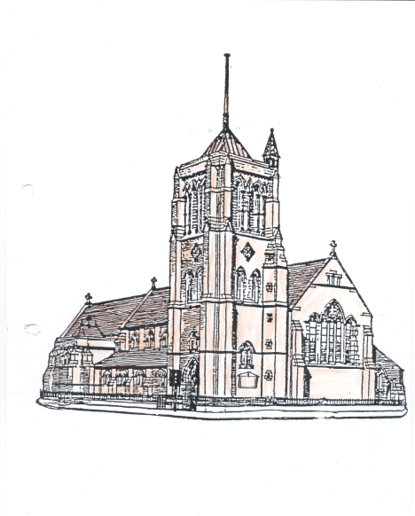
St Aidan and St Columba
Hartlepool

Creation in Christ Sunday

6th September 2026

Please take this pew sheet home with you

Whether this is your first-time visiting St Aidan’s, or whether you are a regular worshipper here, you are most welcome. We would love you to stay after our service for a cup of coffee or tea.

Thank you to everyone who regularly gives money to church. If you too would like to give money, the collection plate is passed around during the offertory hymn, you can also use the contactless machine in church or you can pay money directly into our bank account “St Aidan’s PCC” sort code 050974, account number 15415262.

10.30 am: Sung Mass (St Aidan)
Introit: 450
Gradual: 184
Offertory: 6 verses 1 to 4 and 7
Communion: 566 and 23
Final hymn: 531

6.00 pm: Informal Mass (St Columba)

Readings for today

Isaiah Chapter 55 verses 12 and 13
¹²For you shall go out in joy, and be led back in peace; the mountains and the hills before you shall burst into song, and all the trees of the field shall clap their hands. ¹³Instead of the thorn shall come up the cypress; instead of the brier shall come up the myrtle; and it shall be to the LORD for a memorial, for an everlasting sign that shall not be cut off.

New Testament

Colossians Chapter 1 verses 15-20
¹⁵Christ is the image of the invisible God, the firstborn of all creation; ¹⁶for in him all things in heaven and on earth were created, things visible and invisible, whether thrones or dominions or rulers or powers – all things have been created through him and for him. ¹⁷He himself is before all things, and in him all things hold together. ¹⁸He is the head of the body, the church; he is the beginning, the firstborn from the dead, so that he might come to have first place in everything. ¹⁹For in him all the fullness of God was pleased to dwell, ²⁰and through him God was pleased to reconcile to himself all things, whether on earth or in heaven, by making peace through the blood of his cross.

Gospel

John, Chapter 1 verses 1-14
In the beginning was the Word, and the Word was with God, and the Word was God. ²He was in the beginning with God. ³All things came into being through him, and without him not one thing came into being. What has come into being ⁴in him was life, and the life was the light of all people. ⁵The light shines in the darkness, and the darkness did not overcome it. ⁶There was a man sent from God, whose name was John. ⁷He came as a witness to testify to the light, so that all might believe through him. ⁸He himself was not the light, but he came to testify to the light. ⁹The true light, which enlightens everyone, was coming into the world. ¹⁰He was in the world, and the world came into being through him; yet the world did not know him. ¹¹He came to what was his own, and his own people did not accept him. ¹²But to all who received him, who believed in his name, he gave power to become children of God, ¹³who were born, not of blood or of the will of the flesh or of the will of man, but of God. ¹⁴And the Word became flesh and lived among us, and we have seen his glory, the glory as of a father’s only son, full of grace and truth.



This week’s Notices
Last week Mother Becky pressed the button that launched our new parish website. Please go and have a look when you have time, the site web address is
www.staidan-columba-hartlepool-@co.uk

Bible Study Group - Come along and join us at St Columba’s this Tuesday 8th September when we will be starting to look at the Hebrew Bible and how we read it. The group starts at 7.00 pm.

On Wednesday (9th September) this week Churches Together are meeting in St Georges United Reform Church in Park Road for Morning Prayer, start time is 8.30 am and everyone is welcome.

Bread for the Soul Mass is on every Wednesday at 6.00 pm in St Aidan’s.

The Pub Theology Group meet this Wednesday at 7.15 pm in Jackson’s Wharf Pub.

Some of you will have heard rumours regarding the dissolvement of the Central Hartlepool Group. All Saints Stranton and St Luke’s, without consultation with St Aidan’s and St Columba, wrote to the Archdeacon asking for the group to be dissolved and at this moment in time we don’t know much more. This matter is now in the hands of the Diocese and as soon as we know anything more, we will let you know.

The PCC meet on Monday 14th September at 7.00 pm in St Aidan’s.

There will be no Compline in St Aidan’s until Wednesday September 23rd.

Thursday Evening Cell Group will be starting on 24th September meeting in St Aidan’s Church from 7.00 pm.
This week in our Parish

Monday
9.00 am Morning Prayer in the Vicarage
1.15 pm Ian Thompson’s Funeral in St Aidan’s

Tuesday
8.45 am Morning Prayer in St Columba’s
9.15 am Mass in St Columba’s
10.30 am Cell Group in St Columba’s
10.30 am Dorcas Sewing Group in St Columba’s

Wednesday
10.00 am until 2.00 pm Spiritual Oasis in St Columba’s
11.45 am Wellbeing through the Bible in St Columba’s
1.00 pm Heart of the Week Prayers in St Columba’s
6.00 pm Bread for the Soul Mass in St Aidan’s
7.15 pm Pub Theology in Jackson’s Wharf Pub

Thursday
9.15 am Morning Prayer in St Aidan’s
9.30 am Kitchen in St Aidan’s
11.30 am Kitchen on Tour in St Columba’s
2.00 pm Men’s Group in St Columba’s

Friday
10.00 am Café in St Aidan’s
11.00 am Informal Morning Prayers in St Aidan’s
2.00 pm Meditation in St Columba’s

Sunday – Fifteenth Sunday after Trinity
10.30 am Sung Mass in St Aidan’s
6.00 pm Mustard Seed Mass in St Columba’s

Contacts

Priest in Charge - Mother Becky Reeve 01429 671358
Email: revbeckystaidanandstcolumba@gmail.com

Reader with Permission to Officiate – Ray Turner

Accredited Children’s Minister - Lesley Small
Parish Administrator and Church Office - Kathrine Batty 07836796374
staidans.hartlepool@btconnect.com

Mission Enabler - Partick Reeve Tel: 07720432958 patrick@hartlepoolcoh.co.uk
https://www.facebook.com/hartlepoolcoh/?local

Churchwardens Miss Jane Spears 277773
Mrs Helen Rochester 293727
Deputy Wardens Miss Clair Barker 07494038230
Miss Liz Halford 267575
Safeguarding Mrs Kathrine Batty 07836796374
P.C.C. Secretary Mrs Kathrine Batty 07836796374
P.C.C. Treasurer Mr Tony Batty 07375077210
Gift Aid Secretary Mrs Helen Rochester 293727
Food Store Manager Miss Clair Barker 07494038230

For information and events happening in the parish please look at
https://facebook.com/aidancolumba

