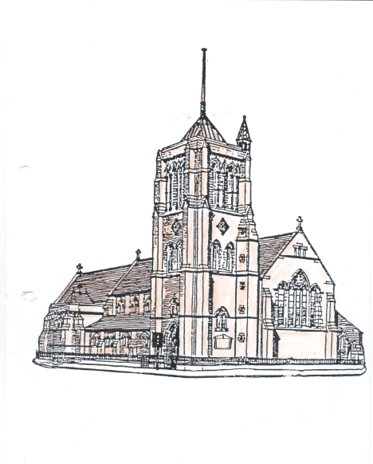
St Aidan and St Columba
Hartlepool

Aidan

30thAugust 2026

Please take this pew sheet home with you

Whether this is your first-time visiting St Aidan’s, or whether you are a regular worshipper here, you are most welcome. We would love you to stay after our service for a cup of coffee or tea.

Thank you to everyone who regularly gives money to church. If you too would like to give money, the collection plate is passed around during the offertory hymn, you can also use the contactless machine in church or you can pay money directly into our bank account “St Aidan’s PCC” sort code 050974, account number 15415262.

10.30 am: Sung Mass (St Aidan)
Introit: Patronal Hymn, please see the words in your service booklet
Psalm response: Such are the ones who seek your face
O Lord.
Offertory: 758
Communion: 318, 623 and 200
Final hymn: 689

6.00 pm: Patronal Sung Evensong (St Aidan)

Readings for today

Old Testament
Isaiah Chapter 61 verses 1-3
1The spirit of the Lord GOD is upon me, because the LORD has anointed me; he has sent me to bring good news to the oppressed, to bind up the broken-hearted, to proclaim liberty to the captives, and release to the prisoners;2to proclaim the year of the LORD’s favour,
and the day of vengeance of our God; to comfort all who mourn;
3to provide for those who mourn in Zion – to give them a garland instead of ashes, the oil of gladness instead of mourning, the mantle of praise instead of a faint spirit. They will be called oaks of righteousness,
the planting of the LORD, to display his glory.

New Testament
Romans Chapter 15 verses 17-21
¹⁷In Christ Jesus, I have reason to boast of my work for God. ¹⁸For I will not venture to speak of anything except what Christ has accomplished through me to win obedience from the Gentiles, by word and deed, ¹⁹by the power of signs and wonders, by the power of the Spirit of God, so that from Jerusalem and as far around as Illyricum I have fully proclaimed the good news of Christ. ²⁰Thus I make it my ambition to proclaim the good news, not where Christ has already been named, so that I do not build on someone else’s foundation, ²¹but as it is written,
‘Those who have never been told of him shall see,
and those who have never heard of him shall understand.’

Gospel
Matthew Chapter 28 verses 16 -20
¹⁶Now the eleven disciples went to Galilee, to the mountain to which Jesus had directed them. ¹⁷When they saw him, they worshipped him; but some doubted. ¹⁸And Jesus came and said to them, ‘All authority in heaven and on earth has been given to me. ¹⁹Go therefore and make disciples of all nations, baptizing them in the name of the Father and of the Son and of the Holy Spirit, ²⁰and teaching them to obey everything that I have commanded you. And remember, I am with you always, to the end of the age.’



This week’s Notices

At 6.00 pm this afternoon everyone is invited to our Patronal Sung Evensong in St Aidan’s. Come and join your church family in Choral worship, thanksgiving and music in honour of St Aidan. After the service everyone is also invited to stay for cake and wine.

There will be no service at St Columba’s this afternoon.

Some of you will have heard rummers regarding the dissolvement of the Central Hartlepool Group. All Saints Stranton and St Luke’s, without consultation with St Aidan’s and St Columba, wrote to the Archdeacon asking for the group to be dissolved and at this moment in time we don’t know much more. This matter is now in the hands of the Diocese and as soon as we know anything more, we will let you know. If you have any questions please ring Mother Becky and she will try to answer.

There will be no Compline in St Aidan’s from Wednesday September 2nd until Wednesday September 23rd.

Come along and join us at St Columba’s from Tuesday 8th September when we will be looking at the Hebrew Bible and how we read it. The group starts at 7.00 pm.

Thursday Evening Cell Group will be starting on 24th September meeting in St Aidan’s Church from 7.00 pm.

PCC dates for September

7th September - Standing Committee meeting 7.00 pm in the Vicarage.

14th September – PCC meeting 7.00 pm in St Aidan’s

This week in our Parish

Monday
9.00 am Morning Prayer in the Vicarage

Tuesday
8.45 am Morning Prayer in St Columba’s
9.15 am Mass in St Columba’s
10.30 am Cell Group in St Columba’s
10.30 am Dorcas Sewing Group in St Columba’s

Wednesday
10.00 am until 2.00 pm Spiritual Oasis in St Columba’s
11.45 am Wellbeing through the Bible in St Columba’s
1.00 pm Heart of the Week Prayers in St Columba’s
6.00 pm Bread for the Soul Mass in St Aidan’s

Thursday
9.15 am Morning Prayer in St Aidan’s
9.30 am Kitchen in St Aidan’s
11.30 am Kitchen on Tour in St Columba’s
2.00 pm Men’s Group in St Columba’s

Friday
10.00 am Café in St Aidan’s
11.00 am Informal Morning Prayers in St Aidan’s
2.00 pm Meditation in St Columba’s

Sunday – Creation in Christ Sunday
10.30 am Sung Mass in St Aidan’s
6.00 pm Mustard Seed Mass in St Columba’s

Contacts

Priest in Charge - Mother Becky Reeve 01429 671358
Email: revbeckystaidanandstcolumba@gmail.com

Reader with Permission to Officiate – Ray Turner

Accredited Children’s Minister - Lesley Small

Parish Administrator and Church Office - Kathrine Batty 07836796374
staidans.hartlepool@btconnect.com

Mission Enabler - Partick Reeve Tel: 07720432958 patrick@hartlepoolcoh.co.uk
https://www.facebook.com/hartlepoolcoh/?local

Churchwardens Miss Jane Spears 277773
Mrs Helen Rochester 293727
Deputy Wardens Miss Clair Barker 07494038230
Miss Liz Halford 267575
Safeguarding Mrs Kathrine Batty 07836796374
P.C.C. Secretary Mrs Kathrine Batty 07836796374
P.C.C. Treasurer Mr Tony Batty 07375077210
Gift Aid Secretary Mrs Helen Rochester 293727
Food Store Manager Miss Clair Barker 07494038230

For information and events happening in the parish please look at
https://facebook.com/aidancolumba

