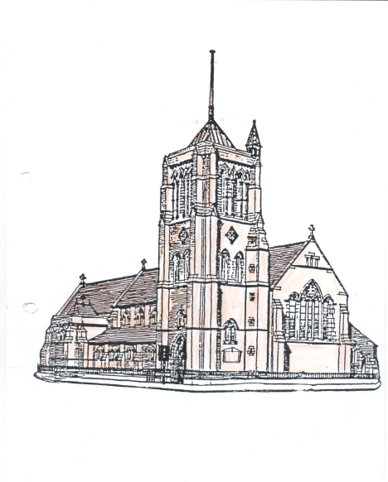
St Aidan and St Columba
Hartlepool

Bartholomew the Apostle

23rd August 2026

Please take this pew sheet home with you

Whether this is your first-time visiting St Aidan’s, or whether you are a regular worshipper here, you are most welcome. We would love you to stay after our service for a cup of coffee or tea.

Thank you to everyone who regularly gives money to church. If you too would like to give money, the collection plate is passed around during the offertory hymn, you can also use the contactless machine in church or you can pay money directly into our bank account “St Aidan’s PCC” sort code 050974, account number 15415262.

10.30 am: Sung Mass (St Aidan)
Introit: 755
Gradual: 17
Offertory: 88
Communion: 72 and 23
Final hymn: 281

6.00 pm: “Mustard Seed” Mass (St Columba)

Readings for today

Old Testament
Isaiah Chapter 43 verses 8-13
⁸Bring forth the people who are blind, yet have eyes, who are deaf, yet have ears! ⁹Let all the nations gather together, and let the peoples assemble. Who among them declared this, and foretold to us the former things? Let them bring their witnesses to justify them, and let them hear and say, ‘It is true.’¹⁰You are my witnesses, says the LORD, and my servant whom I have chosen, so that you may know and believe me and understand that I am he. Before me no god was formed, nor shall there be any after me.¹¹I, I am the LORD, and besides me there is no saviour.¹²I declared and saved and proclaimed, when there was no strange god among you; and you are my witnesses, says the LORD. ¹³I am God, and also henceforth I am He; there is no one who can deliver from my hand; I work and who can hinder it?

New Testament
Acts of the Apostles Chapter 5 verses 12-16
¹²Many signs and wonders were done among the people through the apostles. And they were all together in Solomon’s Portico. ¹³None of the rest dared to join them, but the people held them in high esteem. ¹⁴Yet more than ever believers were added to the Lord, great numbers of both men and women, ¹⁵so that they even carried out the sick into the streets, and laid them on cots and mats, in order that Peter’s shadow might fall on some of them as he came by. ¹⁶A great number of people would also gather from the towns around Jerusalem, bringing the sick and those tormented by unclean spirits, and they were all cured.

Gospel
Luke Chapter 22 verses 24-30
²⁴A dispute also arose among the twelve as to which one of them was to be regarded as the greatest. ²⁵But Jesus said to them, ‘The kings of the Gentiles lord it over them; and those in authority over them are called benefactors. ²⁶But not so with you; rather the greatest among you must become like the youngest, and the leader like one who serves. ²⁷For who is greater, the one who is at the table or the one who serves? Is it not the one at the table? But I am among you as one who serves.²⁸You are those who have stood by me in my trials; ²⁹and I confer on you, just as my Father has conferred on me, a kingdom, ³⁰so that you may eat and drink at my table in my kingdom, and you will sit on thrones judging the twelve tribes of Israel.’

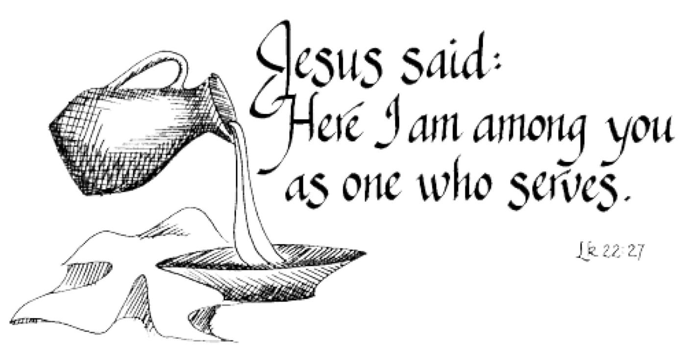

This week’s Notices

Choir Practise will be in St Aidan’s tomorrow evening at 5.30 pm for choir members and those wishing to sing with the choir for our Patronal Evensong.

Pub Theology Group is on Wednesday of this week at 7.15 pm in Jackson’s Wharf.

Next Sunday, 30th August, is St Aidan’s Patronal Festival, on that day we will have our 10.30 am Mass in the morning, then at
6.00 pm everyone is invited to a Patronal Evensong followed by refreshments and a glass of wine.
Please put your name on the list in church if you are coming to the Patronal Evensong so that we know how many people to cater for.

There will be no service at St Columba’s next Sunday.

Hartlepool Vue cinema is showing an animated film called
David (PG) which is based on 1 Samuel. The time of the film each day is 12.45 pm and is screening until Thursday.

Dates for September

7th September - Standing Committee meeting 7.00 pm in the Vicarage.

14th September – PCC meeting 7.00 pm in St Aidan’s

This week in our Parish
Monday
9.00 am Morning Prayer in the Vicarage

Tuesday
8.45 am Morning Prayer in St Columba’s
9.15 am Mass in St Columba’s
10.30 am Cell Group in St Columba’s
10.30 am Dorcas Sewing Group in St Columba’s

Wednesday
10.00 am until 2.00 pm Spiritual Oasis in St Columba’s
11.45 am Wellbeing through the Bible in St Columba’s
1.00 pm Heart of the Week Prayers in St Columba’s
6.00 pm Bread for the Soul Mass in St Aidan’s
6.45 pm Compline in St Aidan’s
7.15 pm Pub Theology at Jackson’s Wharf

Thursday
9.15 am Morning Prayer in St Aidan’s
9.30 am Kitchen in St Aidan’s
11.30 am Kitchen on Tour in St Columba’s
2.00 pm Men’s Group in St Columba’s

Friday
10.00 am Café in St Aidan’s
11.00 am Informal Morning Prayers in St Aidan’s
2.00 pm Meditation in St Columba’s

Sunday 30th August – Aidan
10.30 am Patronal Festival Sung Mass in St Aidan’s

6.00 pm Patronal Sung Evensong in St Aidan’s with refreshments afterwards

Contacts

Priest in Charge - Mother Becky Reeve 01429 671358
Email: revbeckystaidanandstcolumba@gmail.com

Reader with Permission to Officiate – Ray Turner

Accredited Children’s Minister - Lesley Small

Parish Administrator and Church Office - Kathrine Batty 07836796374
staidans.hartlepool@btconnect.com

Mission Enabler - Partick Reeve Tel: 07720432958 patrick@hartlepoolcoh.co.uk
https://www.facebook.com/hartlepoolcoh/?local

Churchwardens Miss Jane Spears 277773
Mrs Helen Rochester 293727
Deputy Wardens Miss Clair Barker 07494038230
Miss Liz Halford 267575
Safeguarding Mrs Kathrine Batty 07836796374
P.C.C. Secretary Mrs Kathrine Batty 07836796374
P.C.C. Treasurer Mr Tony Batty 07375077210
Gift Aid Secretary Mrs Helen Rochester 293727
Food Store Manager Miss Clair Barker 07494038230

For information and events happening in the parish please look at
https://facebook.com/aidancolumba

